Lab Assignment 1.5– AI Assisted Coding

SALENDRA NAGARAJU

2303A51361
Batch:20
Install and configure GitHub Copilot in VS Code. Take screenshots of each step.
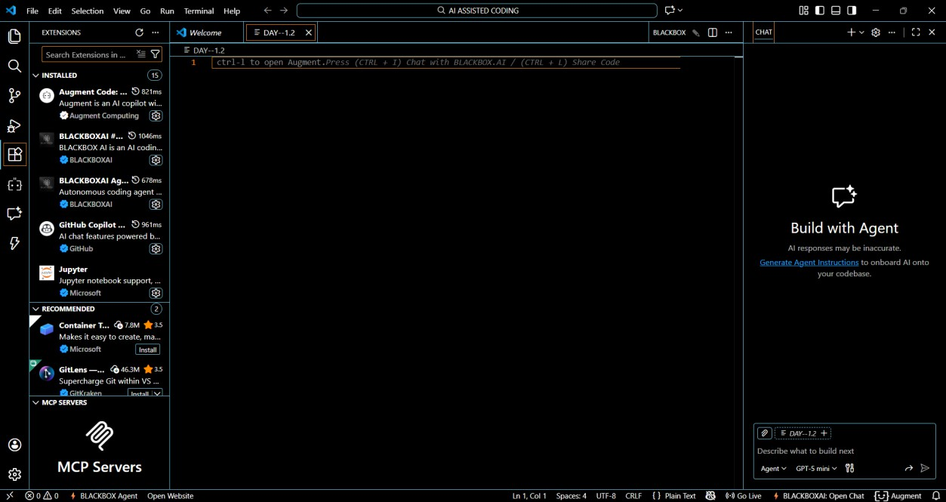
Searched for copilot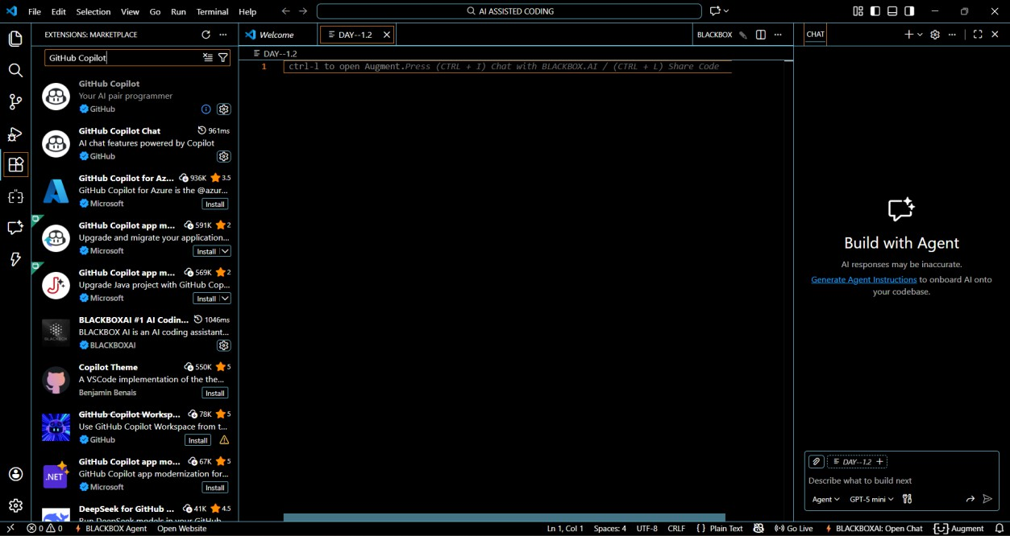

- Clicked Install
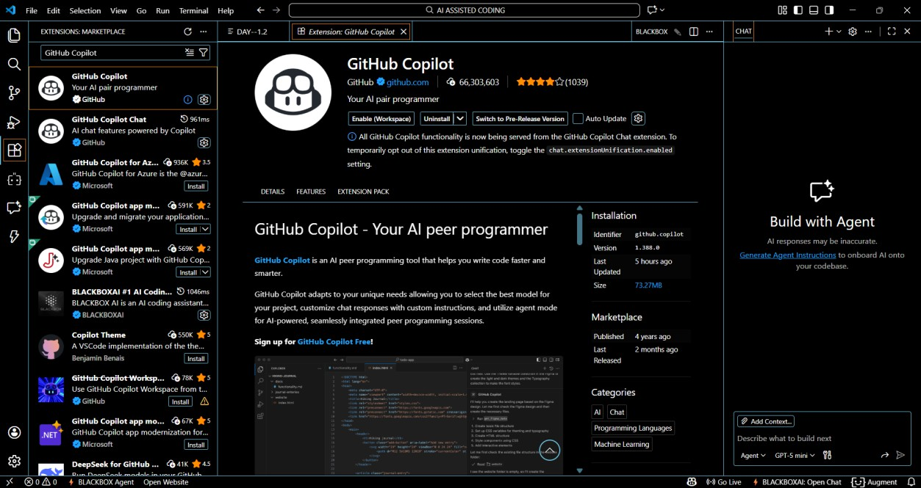
- Signed in with GitHub Account
- Enabled Copilot suggestions
- Verified Copilot inline suggestions in Python file
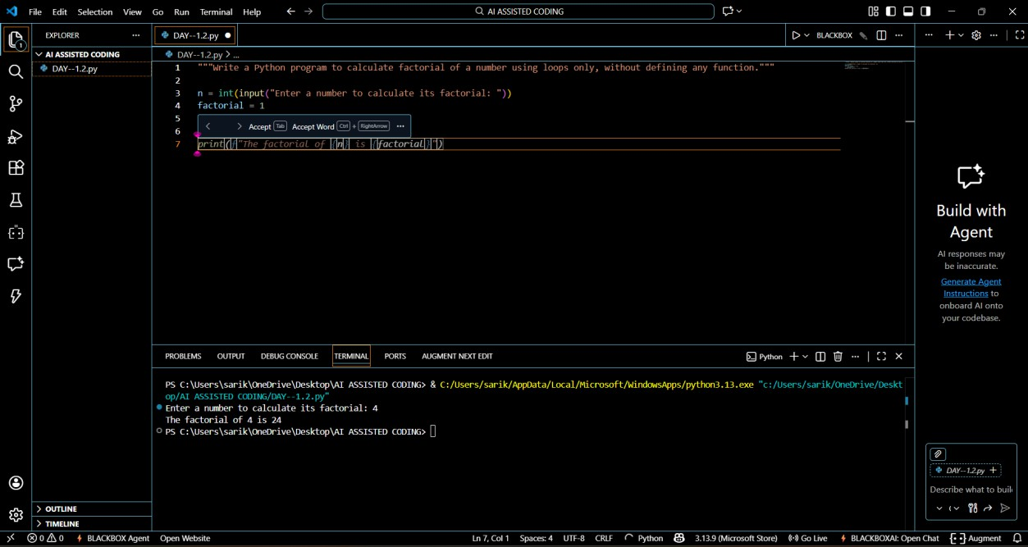

Task 1: AI-Generated Logic Without Modularization (String Reversal Without

Functions)
Prompt Used: “Generate a python code to reverse a given string which accepts the user input and does not use any user-defined functions.”
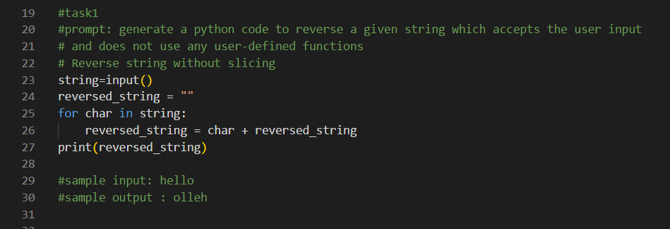

Expected Output Explanation
The program successfully reverses the input string by iterating through the characters in reverse order using a loop. Since no user-defined functions or built-in reversal methods are used, the logic remains fully procedural and easy to trace step by step.
Observations
GitHub Copilot accurately generated the required logic based on the provided comments. The generated code follows all constraints and produces correct output. This approach is suitable for small, single-use programs; however, it lacks reusability and scalability for larger applications
Task 2: Efficiency & Logic Optimization (Readability Improvement)
ORIGINAL CODE:
Prompt Used: “Simplify this string reversal code”
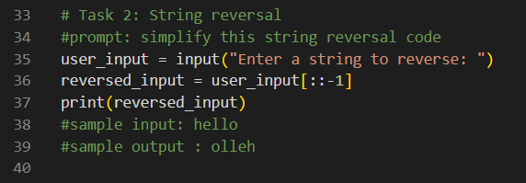

Expected Output Explanation
The original code reverses the string using a loop and an extra variable. It works, but it is a little long and harder to read.The optimized code uses slicing to reverse the string in one line. This makes the code shorter, cleaner, and easier to understand.
Observation
GitHub Copilot gives correct code. When we ask it to optimize, it gives a better and simpler solution. AI helps in coding, but we should always check the code.

Task 3: Modular Design Using AI Assistance (String Reversal Using Functions
Prompt Used: “Write a Python function to reverse a string with comments”
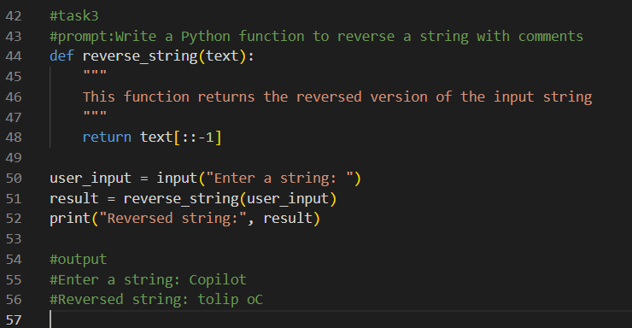

Expected Output Explanation
The function reverse_string() takes a string as input and returns the reversed string using slicing. The main program calls this function and prints the result. Comments are added to explain what the function does.

Observation
Using a function makes the code easy to reuse, easy to understand, and easy to maintain. GitHub Copilot correctly generated a clean and readable function when given a clear prompt.

Task 4: Comparative Analysis – Procedural vs Modular Approach (With vs Without Functions)

Comparison Table

Aspect | Without Functions (Procedural) | With Functions (Modular)
Code Clarity | Logic is mixed in main code | Code is well organized
Reusability | Cannot be reused easily | Can be reused anywhere
Debugging Ease | Debugging is harder | Debugging is easier
Large-Scale Use | Not suitable | Suitable

Short Analytical Report

The procedural approach without functions is simple and easy to write for small programs. However, the code becomes difficult to manage and reuse as the program grows.

The modular approach using functions improves clarity and reusability. It makes debugging easier and is more suitable for large-scale applications. Therefore, using functions is the better design choice for real-world and collaborative software development.

Conclusion

Function-based (modular) programming is preferred over procedural programming for clean, reusable, and maintainable code.

Task 5: AI-Generated Iterative vs Recursive Fibonacci Approaches (Different Algorithmic Approaches to String Reversal)
Prompt Used: “Write a Python program to reverse a string using a loop.Take input from the user. Do not use built-in functions or slicing. Implement logic in the main program”

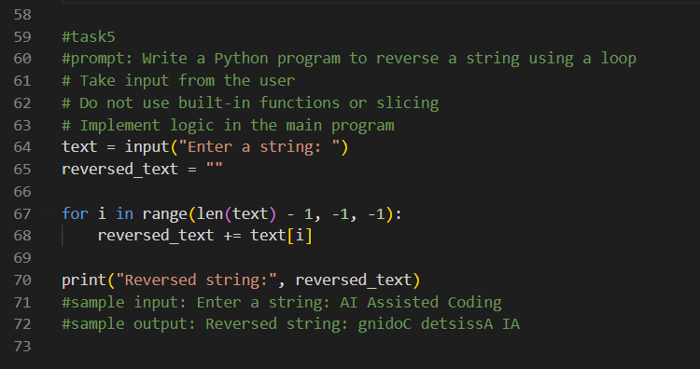

Comparison
- Execution Flow:
Loop-based method reverses the string step by step.
Slicing method reverses the string in one line.
- Time Complexity:
Both methods have O(n) time complexity.
- Performance for Large Inputs:
Slicing is faster because it is internally optimized in Python.
- When to Use:
Loop-based method is good for learning logic.
Slicing method is better for real applications.

Observation
GitHub Copilot can generate different correct solutions, and choosing the best one depends on readability and performance.

